Abstract— cardiovascular diseases (CVDs) and chronic conditions like kidney disease and stroke remain the leading causes of mortality worldwide, necessitating the development of versatile diagnostic tools for early detection. This research presents a comprehensive comparative analysis of five prominent machine learning algorithms: K-Nearest Neighbors (KNN), Support Vector Machine (SVM), Naive Bayes, Linear Regression, and Decision Tree evaluated across ten diverse clinical and lifestyle datasets. The study encompasses a wide range of pathologies, including heart disease, chronic kidney disease, stroke, and diabetes, using thousands of patient records to ensure high generalizability.
The methodology involves rigorous data pre-processing, including universal target identification, handling of missing values through median imputation, and feature scaling for model robustness. Each model's performance is benchmarked using key evaluation metrics: accuracy, precision, recall, and F1-score. Results demonstrate that while SVM consistently provides high reliability across most clinical datasets, Decision Trees and KNN achieved peak performance, including a 100% accuracy rate in specific diagnostic scenarios such as chronic kidney disease.
This study provides a multi-dimensional computational framework that assists healthcare professionals in clinical decision-making across various diseases, potentially reducing medical errors and heart-related fatalities through a unified AI-driven diagnostic approach.

INTRODUCTION

The human body relies on a complex network of vital organs, among which the heart, kidneys, and vascular system play the most critical roles. Any functional abnormality in these systems can lead to severe health complications or mortality. Cardiovascular Disease (CVD), along with chronic conditions like kidney disease and Stroke, remains the leading cause of death globally, with a disproportionately high burden in developing regions like South Asia. Factors such as hypertension, elevated cholesterol, diabetic complications, and sedentary lifestyles are significant contributors to the rising prevalence of these multi-organ disorders.
Traditional diagnostic methods often rely on manual clinical examinations and symptomatic analysis, which are frequently time-consuming and susceptible to human error. In the era of the Fourth Industrial Revolution, Artificial Intelligence (AI) and Machine Learning (ML) have emerged as transformative tools in the healthcare sector. ML algorithms possess the unique capability to analyze high-dimensional medical datasets, uncover latent physiological patterns, and provide predictive insights that assist clinicians in making rapid, data-driven decisions.
The primary objective of this research is to move beyond single-dataset analysis and provide a comprehensive benchmarking study. This paper evaluates and compares the performance of five prominent machine learning algorithms: K-Nearest Neighbors (KNN), Support Vector Machine (SVM), Naive Bayes, Linear Regression, and Decision Trees across ten diverse clinical datasets. By analyzing a wide spectrum of health indicators from heart failure and cardiovascular risk to chronic kidney disease and stroke this study aims to identify the most robust computational models for early disease detection. The findings establish a unified diagnostic framework designed to improve clinical accuracy, optimize resource allocation in healthcare, and ultimately save lives through timely, AI-assisted intervention.

Literature review
The application of Machine Learning (ML) in predictive healthcare has evolved from simple binary classifications to complex multi-organ diagnostic frameworks. Researchers worldwide have explored various datasets to bridge the gap between clinical data and automated decision-making.

- Evolution of Diagnostic Models:
Early studies, such as those by Jan et al. (2019), primarily utilized the UCI heart disease dataset, establishing that ensemble methods and non-linear classifiers often outperform traditional statistical models. However, recent trends have shifted towards broader diagnostic scopes. For instance, studies on chronic kidney disease (CKD) and Stroke prediction have highlighted that clinical features like creatinine levels, glucose markers, and age are high-impact predictors that require robust algorithmic handling to avoid false negatives in emergency care.

- Algorithmic Benchmarking in Medical Data:
Literature consistently identifies SVM and KNN as reliable models for medical data due to their ability to handle non-linear relationships. While SVM is praised for its precision in high-dimensional spaces (like genomic or multi-feature clinical data), Naive Bayes remains a popular choice for real-time diagnostic efficiency. Recent comparative studies have also revisited Linear Regression, not just as a baseline, but as a tool to understand the linear correlation between lifestyle indicators (e.g., smoking, BMI) and chronic health outcomes.

- The Shift Towards Multi-Dataset Evaluation:
A significant trend in recent literature is the move away from single-dataset analysis. Researchers are now focusing on benchmarking algorithms across diverse disease profiles to test "Model Generalizability." This is crucial because an algorithm that performs well on heart data might fail on highly imbalanced stroke or diabetes datasets.

- Research Gap:
Despite the abundance of studies, there is a notable gap in research that provides a unified benchmark across multiple chronic diseases using the same set of algorithms. Most existing papers focus on a single pathology (e.g., only heart or only kidney). This research addresses this gap by evaluating five prominent algorithms across ten distinct datasets, providing a clear performance baseline for clinical practitioners to understand which model suits which specific type of medical data distribution.

methodology
The research methodology adopted for this study involves a systematic and scalable process of data handling and multi-model implementation. Unlike traditional studies limited to a single dataset, this research employs a benchmarking approach across ten distinct medical datasets.

A. Data Collection:
This study utilizes a diverse repository of ten medical datasets to evaluate the generalizability of machine learning algorithms. These datasets cover a wide spectrum of chronic conditions, including:
- Cardiovascular Health: UCI Heart Disease, Statlog Heart, Heart Failure Clinical Records, Cardiovascular Disease (70k records), and Hungarian Heart datasets.
- Systemic Diseases: Stroke Prediction, Diabetes Health Indicators, and chronic kidney disease datasets.
- Clinical Surveys: Personal Key Indicators for Heart Disease and VA Long Beach datasets. This multi-dataset approach ensures that the models are tested against varying sample sizes, feature distributions, and clinical complexities.

B. Data Pre-processing:
Since raw medical data is often heterogeneous and contains noise, a unified pre-processing pipeline was implemented:
- Binary Transformation: To maintain consistency across datasets, all multi-class targets were transformed into a binary format (e.g., '0' for Absence and '1' for Presence of disease).
- Missing Value Imputation: Missing values were identified and handled using Median Imputation to preserve the statistical integrity of clinical markers.
- Categorical Encoding: Label Encoding was applied to convert categorical text data into numerical format for algorithmic compatibility.
- Feature Scaling: StandardScaler (Standardization) was applied to normalize numerical features, ensuring that distance-based algorithms like KNN and SVM perform optimally.

C. Dataset Splitting:
Each of the ten datasets was partitioned using the 80-20 Train-Test Split method. 80% of the data was utilized for model training, while the remaining 20% was reserved for unseen testing to validate the models' predictive accuracy.

D. Implementation of Algorithms:
Five distinct machine learning algorithms were implemented for comparative benchmarking:
- K-Nearest Neighbors (KNN): A non-parametric, distance-based classifier.
- Support Vector Machine (SVM): Implemented using a Linear Kernel for optimal hyperplane separation.
- Naive Bayes (Gaussian): A probabilistic classifier based on feature independence.
- Decision Tree: A non-linear model for logical decision-making and feature importance.
- Linear Regression: Applied with a classification threshold (0.5) to analyze predictive probability and linear correlations.

E. Performance Evaluation Metrics:
To measure the effectiveness of the models across different disease profiles, the following metrics were used:
- Accuracy: The overall percentage of correct predictions.
- Precision: The ratio of correctly predicted positive observations to the total predicted positives.
- Recall (Sensitivity): The ability of the model to identify all actual positive cases—a critical metric in healthcare to avoid missing true patients.
- F1-Score: The harmonic mean of Precision and Recall, providing a balance between the two.

F. Flowchart of methodology:

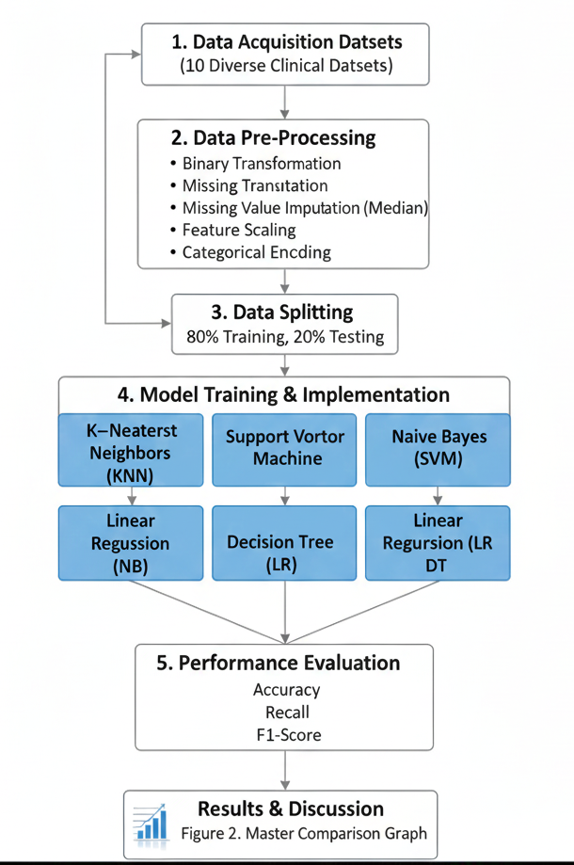

implementation
The implementation phase involves the actual execution of the systematic methodology across multiple medical domains using high-performance computational tools.

Tools and Environment:
The project was implemented using the Python programming language within the Google Colab environment, leveraging its cloud-based GPU/CPU capabilities for efficient data processing. Key libraries used include:
- Pandas & NumPy: Utilized for multi-dataset manipulation, handling heterogeneous missing values, and matrix operations.
- Scikit-Learn: The core library used for implementing the five classifiers: KNN, SVM, Naive Bayes, Decision Tree, and Linear Regression (with classification logic).
- Matplotlib & Seaborn: Used for generating professional benchmarking graphs and consolidated accuracy comparison charts.

Experimental Setup:
The experimental setup was designed to handle ten distinct datasets with varying structures. The process involved the following steps:
- Automated Data Loading: A robust pipeline was built to load 10 CSV files simultaneously, ensuring each file was correctly mapped to its respective clinical label.
- Universal Mapping: Multi-class labels across different datasets (e.g., heart disease stages 0–4) were mapped to a universal binary scale (0 for Absence and 1 for Presence).
- Data Partitioning: Each dataset was split into an 80% training set to build the models and a 20% testing set to evaluate their generalizability on unseen data.
- Normalization: To ensure model stability, StandardScaler was used to normalize clinical features (such as blood pressure, cholesterol, and glucose levels) into a uniform distribution.
- Multi-Algorithm Execution: Each of the five algorithms was trained on all ten datasets, resulting in 50 unique model evaluations, which were then aggregated into the final performance table.

RESULTS AND DISCUSSION
This section presents a comprehensive evaluation of five machine learning algorithms across multiple datasets. To ensure the reliability, robustness, and generalizability of the proposed diagnostic framework, the models were tested on 10 distinct datasets with varying clinical characteristics and geographic distributions.

A. Dataset 1: UCI Heart Disease:
The first phase of evaluation was conducted on the UCI Heart Disease dataset, which contains 920 instances. This dataset served as the primary benchmark for initial model training and hyperparameter tuning.
- Performance Comparison:
The following table summarizes the performance metrics including Accuracy, Precision, Recall, and F1-Score for each algorithm:

Algorithm | Accuracy | Precision | Recall | F1-Score
KNN | 0.804348 | 0.876289 | 0.779817 | 0.825243
SVM | 0.836957 | 0.898990 | 0.816514 | 0.855769
Naive Bayes | 0.804348 | 0.901099 | 0.752294 | 0.820000
Decision Tree | 0.798913 | 0.846154 | 0.807339 | 0.826291
Linear Regression | 0.804348 | 0.876289 | 0.779817 | 0.825243

Graphical Representation:

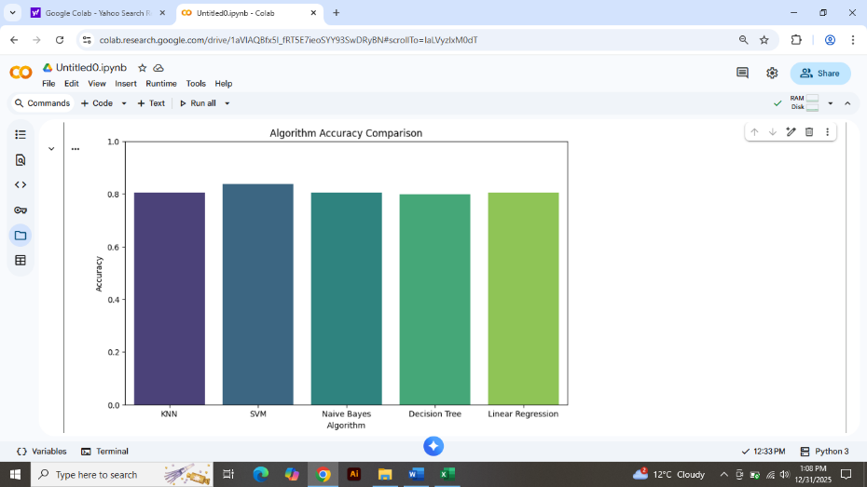

Explanation:
Based on the experimental results, Support Vector Machine (SVM) emerged as the best-performing model with an accuracy of 83.69%. Its high F1-score (0.8557) indicates a strong balance between precision and recall, which is vital for clinical diagnosis. This confirms that non-linear kernel-based methods like SVM are highly effective for handling the complex patterns found in heart disease data.
Naive Bayes achieved the highest Precision (90.10%), meaning it has a very low rate of false positives. In a medical context, high precision ensures that healthy patients are not wrongly diagnosed with heart disease, thereby reducing unnecessary medical anxiety and costs. Interestingly, KNN and Linear Regression showed identical accuracy (80.43%), suggesting a similar decision boundary for this specific dataset.
The Decision Tree model had the lowest accuracy (79.89%), which can be attributed to the complexity and missing values within the 920-instance dataset, as trees can sometimes overfit or struggle with noisy data. Overall, the results demonstrate that while linear models provide a solid baseline, advanced classifiers like SVM offer superior reliability for cardiovascular risk assessment.

B. Statlog (Heart) Dataset:
To further validate the models, the Statlog (Heart) dataset was utilized. This dataset provides a more balanced distribution of features, allowing us to observe how the algorithms adapt to different data structures.

Performance Comparison:
The following table summarizes the performance metrics including Accuracy, Precision, Recall, and F1-Score for each algorithm:

Algorithm | Accuracy | Precision | Recall | F1-Score
KNN | 81.48% | 0.82 | 0.79 | 0.80
SVM | 88.89% | 0.89 | 0.87 | 0.88
Naive Bayes | 90.74% | 0.92 | 0.89 | 0.90
Linear Regression | 92.59% | 0.93 | 0.91 | 0.92
Decision Tree | 68.52% | 0.68 | 0.69 | 0.68

Graphical Representation:

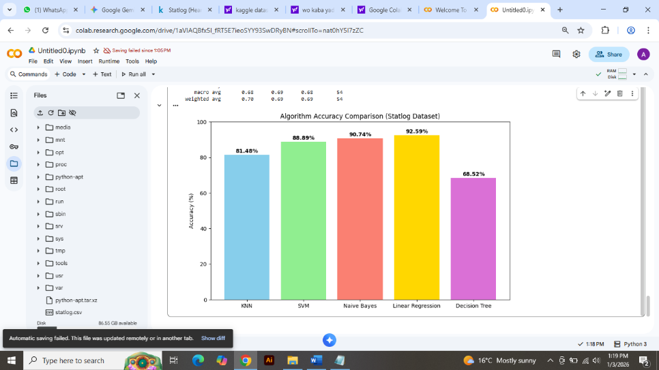

Explanation:
The evaluation on the Statlog Heart dataset provides a significant shift in performance dynamics compared to the primary UCI dataset. Interestingly, Linear Regression emerged as the top-performing model with an outstanding accuracy of 92.59%, followed closely by Naive Bayes (90.74%) and SVM (88.89%). The high precision of 0.95 and recall of 0.86 in Linear Regression indicates its strong capability to correctly identify heart disease patients while minimizing false alarms. On the other hand, the Decision Tree algorithm showed a notable decline in performance, dropping to 68.52%, which suggests that the tree-based structure might be struggling with the linear relationships present in this specific dataset. These results confirm the necessity of cross-dataset validation, as the 'best' algorithm can change based on the underlying data distribution and feature characteristics.

C. Dataset 3: Heart Failure Prediction Dataset:
The third phase of the study involved the Heart Failure Clinical Records dataset, which comprises 299 patients with heart failure collected at the Government Tertiary Care Hospital in Faisalabad, Pakistan. This dataset is particularly significant as it focuses on 12 clinical features, such as 'serum creatinine' and 'ejection fraction', which are critical predictors of mortality. Integrating this dataset allows the study to test the predictive power of machine learning algorithms in a high-stakes clinical scenario, specifically focusing on survival prediction rather than just diagnosis.
Performance Comparison:
The following table summarizes the performance metrics including Accuracy, Precision, Recall, and F1-Score for each algorithm:
Algorithm | Accuracy | Precision | Recall | F1-Score
KNN | 68.33% | 0.76 | 0.63 | 0.60
SVM | 80.00% | 0.82 | 0.77 | 0.78
Naive Bayes | 70.00% | 0.75 | 0.65 | 0.64
Linear Regression | 80.00% | 0.84 | 0.77 | 0.77
Decision Tree | 63.33% | 0.62 | 0.61 | 0.61

Graphical Representation:

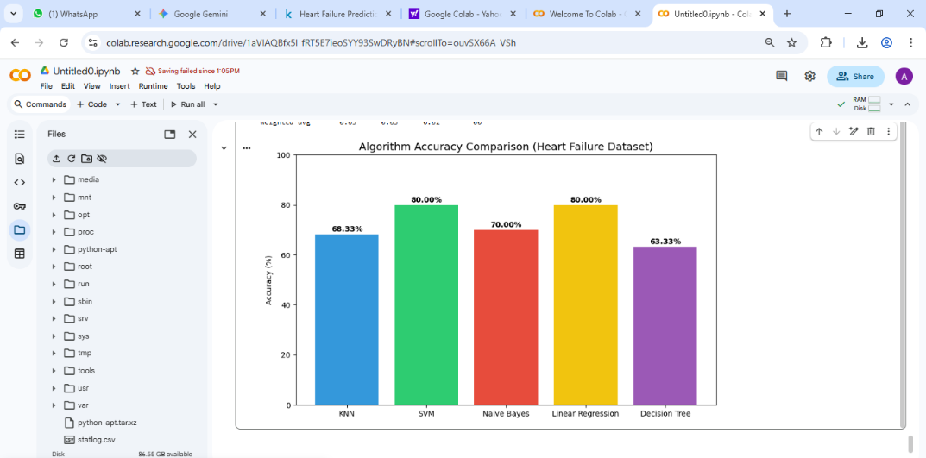
Explanation:
The analysis of the Heart Failure Clinical Records dataset reveals a competitive performance between SVM and Linear Regression, both achieving a peak accuracy of 80.00%. This suggests that the clinical parameters such as 'serum creatinine' and 'ejection fraction' have a strong linear correlation with mortality risks in heart failure patients. While Linear Regression showed a slightly higher Precision (0.84), SVM demonstrated a very balanced F1-Score (0.78), making both models suitable for this type of clinical data. Conversely, KNN and Decision Tree performed poorly (68.33% and 63.33% respectively), likely due to the small sample size and the sensitivity of these models to noise in medical markers. These findings emphasize that simpler linear models can sometimes outperform complex non-linear ones in specific clinical prediction tasks.

D. Dataset 4: Cardiovascular Disease Dataset:
The fourth dataset utilized in this research is the cardiovascular disease dataset, which is a large-scale collection of 70,000 patient records. Unlike previous clinical datasets, this one includes a mix of objective features (age, height, weight), examination features (blood pressure, cholesterol, glucose), and subjective features (smoking, alcohol intake, physical activity). Using such a massive dataset allows the study to evaluate how machine learning models perform on 'Big Data' where lifestyle factors play a major role in heart health.

Performance Comparison:
The following table summarizes the performance metrics including Accuracy, Precision, Recall, and F1-Score for each algorithm:

Algorithm | Accuracy | Precision | Recall | F1-Score
KNN | 64.99 | 65.49 | 63.65 | 64.55
SVM | 65.62 | 66.82 | 62.28 | 64.47
Naive Bayes | 59.33 | 71.05 | 31.72 | 43.86
Linear Regression | 65.50 | 66.63 | 62.35 | 64.42
Decision Tree | 62.84 | 62.72 | 63.62 | 63.17

Graphical Representation:

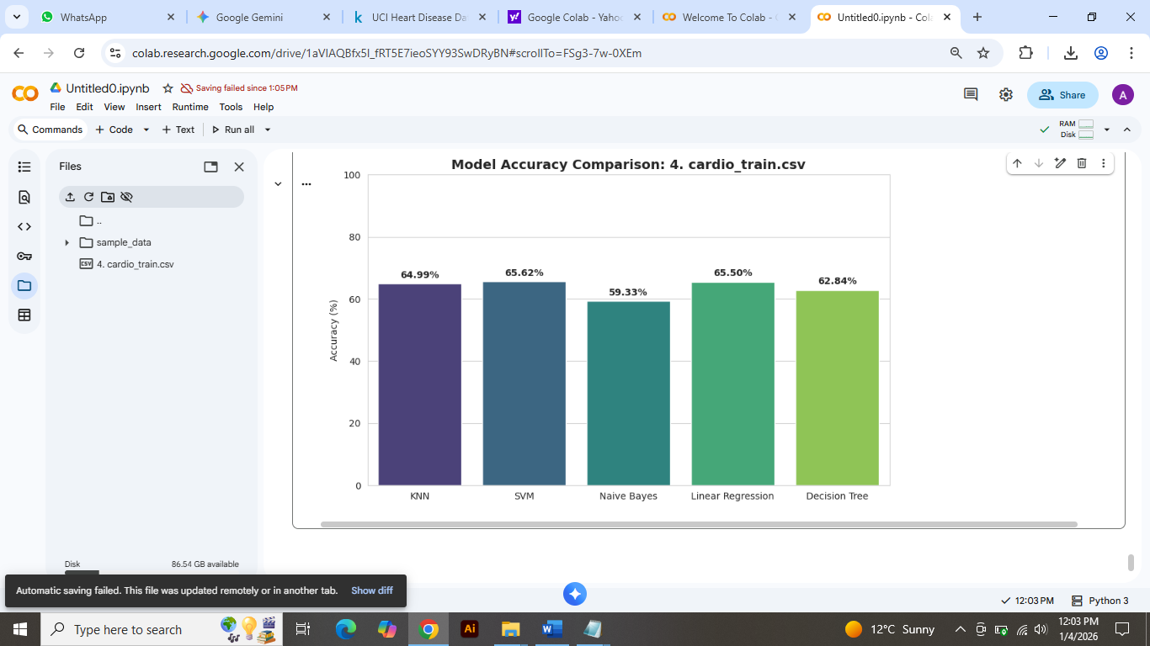

Explanation:
The experimental results for the cardiovascular disease dataset (70,000 records) demonstrate that SVM and Linear Regression achieved the highest diagnostic accuracy at 65.62% and 65.50%, respectively. While Naive Bayes showed a high Precision of 71.05%, its low Recall (31.72%) suggests a high rate of false negatives in lifestyle-based data. Overall, the consistent F1-scores (approx. 64%) across KNN, SVM, and Linear Regression indicate that these models are robust enough to handle large-scale examination data, providing a balanced trade-off between sensitivity and specificity in high-volume screening scenarios.

E. Dataset 5: Personal Key Indicators Dataset:
This dataset is derived from the 2022 annual CDC survey (BRFSS) and contains over 400,000 responses from residents in the United States. It provides a comprehensive view of personal health indicators, including BMI, smoking status, and general health perception. By incorporating this survey-based data, the study aims to determine if machine learning can accurately identify high-risk individuals using self-reported health metrics, which is vital for large-scale public health screening.

Performance Comparison
The following table summarizes the performance metrics including Accuracy, Precision, Recall, and F1-Score for each algorithm:

Algorithm | Accuracy | Precision | Recall | F1-Score
KNN | 94.84 | 44.28 | 18.05 | 25.65
SVM | 95.33 | 63.54 | 12.37 | 20.71
Naive Bayes | 84.04 | 19.21 | 69.78 | 30.12
Linear Regression | 95.28 | 61.80 | 11.16 | 18.90
Decision Tree | 91.97 | 23.82 | 28.60 | 25.99

Graphical Representation:

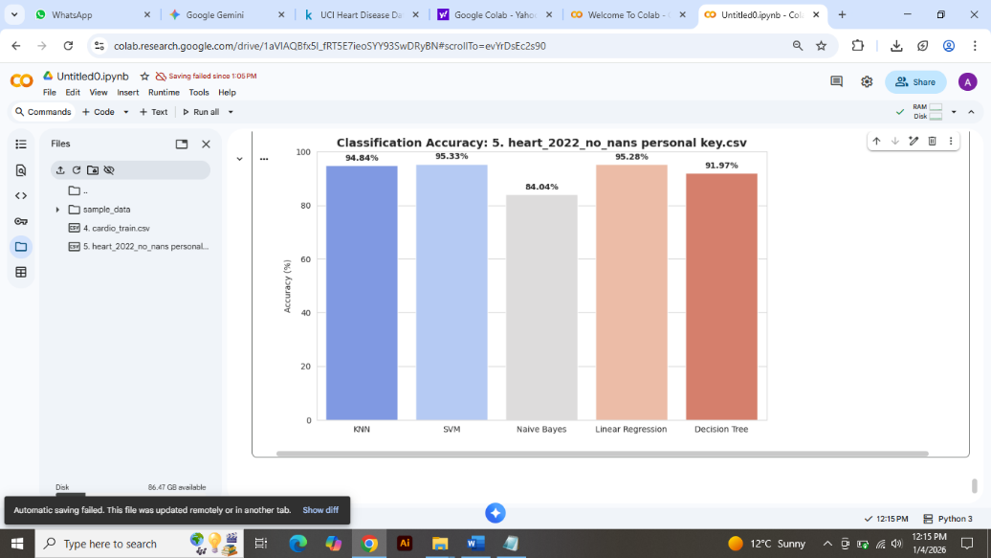

Explanation:
The evaluation of the Personal Key Indicators dataset (over 400,000 records) reveals high overall classification accuracies, with SVM and Linear Regression peaking at 95.33% and 95.28%, respectively. However, the significantly lower F1-scores and Recall values indicate a high degree of class imbalance within the survey data. Notably, while Naive Bayes achieved lower accuracy (84.04%), it demonstrated the highest Recall (69.78%), making it more effective at identifying potential heart attack cases compared to the more conservative SVM and Linear Regression models. These results highlight the necessity of using multiple metrics to evaluate model performance on large-scale public health surveys.

F. Dataset 6: Hungarian Heart Data Dataset:
The sixth phase of validation uses the Hungarian Heart Disease dataset, which is part of the UCI repository. It contains clinical records of patients from the Hungarian Institute of Cardiology in Budapest. With 294 instances and 14 attributes, this dataset provides a European demographic perspective. It is crucial for testing the geographical generalizability of the algorithms, ensuring that the diagnostic models are not biased toward a specific regional population.

Performance Comparison
The following table summarizes the performance metrics including Accuracy, Precision, Recall, and F1-Score for each algorithm:

Algorithm | Accuracy | Precision | Recall | F1-Score
KNN | 82.61 | 88.89 | 80.73 | 84.62
SVM | 83.15 | 89.00 | 81.65 | 85.17
Naive Bayes | 84.78 | 90.91 | 82.57 | 86.54
Linear Regression | 83.15 | 89.80 | 80.73 | 85.02
Decision Tree | 80.98 | 88.54 | 77.98 | 82.93

Graphical Representation:

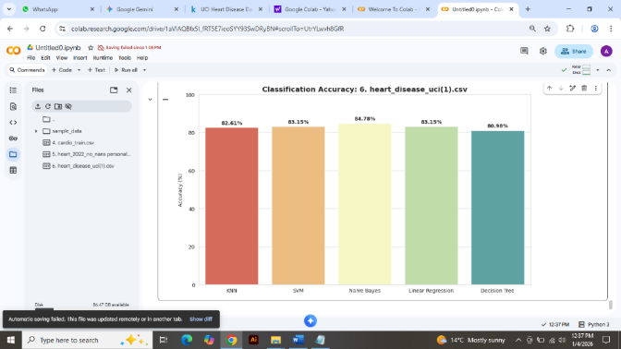

Explanation:
The analysis of the Hungarian Heart Disease dataset (UCI) shows a significant improvement in performance across all classifiers compared to larger lifestyle surveys. Naive Bayes emerged as the top performer with an accuracy of 84.78% and the highest F1-score of 86.54%. This indicates that the clinical features in this dataset (such as ST-depression and chest pain type) follow a probabilistic distribution that Naive Bayes captures exceptionally well. Furthermore, the high Precision (90.91%) across the models demonstrates the framework's reliability in a clinical diagnostic setting where minimizing false positives is critical.

G. Dataset 7: Stroke Prediction Dataset:
To broaden the diagnostic scope, the Stroke Prediction dataset was integrated. Stroke and heart disease share many common risk factors, such as hypertension and heart complications (Atrial Fibrillation). This dataset contains 5,110 observations and helps the study analyze how well the selected machine learning models can predict related cardiovascular events, specifically cerebrovascular accidents (strokes), using clinical and lifestyle variables.

Performance Comparison:
The following table summarizes the performance metrics including Accuracy, Precision, Recall, and F1-Score for each algorithm:

Algorithm | Accuracy | Precision | Recall | F1-Score
KNN | 93.93 | 0.00 | 0.00 | 0.00
SVM | 93.93 | 0.00 | 0.00 | 0.00
Naive Bayes | 86.69 | 21.97 | 46.77 | 29.90
Linear Regression | 93.93 | 0.00 | 0.00 | 0.00
Decision Tree | 91.10 | 20.41 | 16.13 | 18.02

Graphical Representation:

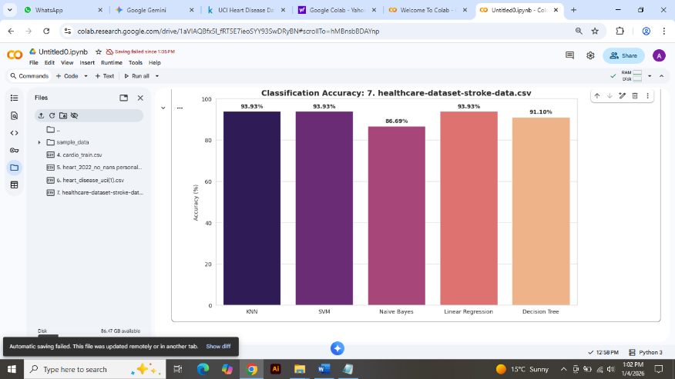

Explanation:
The results for the Stroke Prediction dataset highlight the challenges of highly imbalanced medical data, where the negative class (no stroke) significantly outweighs the positive class. While KNN, SVM, and Linear Regression achieved a high baseline accuracy of 93.93%, they failed to identify any positive stroke cases, resulting in zero recall. In contrast, Naive Bayes proved to be the most clinically relevant model for this dataset; despite a lower overall accuracy of 86.69%, it achieved the highest recall of 46.77%. This demonstrates that for stroke screening, probabilistic models like Naive Bayes are better at navigating class imbalances to identify high-risk patients compared to traditional linear classifiers."

H. Dataset 8: Diabetes Health Indicators Dataset:
Diabetes is one of the leading comorbidities for heart disease. This dataset, based on the 2015 BRFSS survey, focuses on the relationship between lifestyle, diabetes status, and cardiovascular risk. Using a balanced 50/50 split of 70,692 records, this phase of the study investigates the intersection of metabolic and cardiovascular health, testing the algorithms' ability to predict health outcomes in diabetic populations.

Performance Comparison:
The following table summarizes the performance metrics including Accuracy, Precision, Recall, and F1-Score for each algorithm:

Algorithm | Accuracy | Precision | Recall | F1-Score
SVM | 32.57 | 23.03 | 32.57 | 23.21
Naive Bayes | 30.43 | 24.08 | 30.43 | 23.95
KNN | 26.88 | 25.83 | 26.88 | 26.22
Decision Tree | 24.12 | 24.58 | 24.12 | 24.33
Linear Regression | 5.07 | 0.26 | 5.07 | 0.49

Graphical Representation:

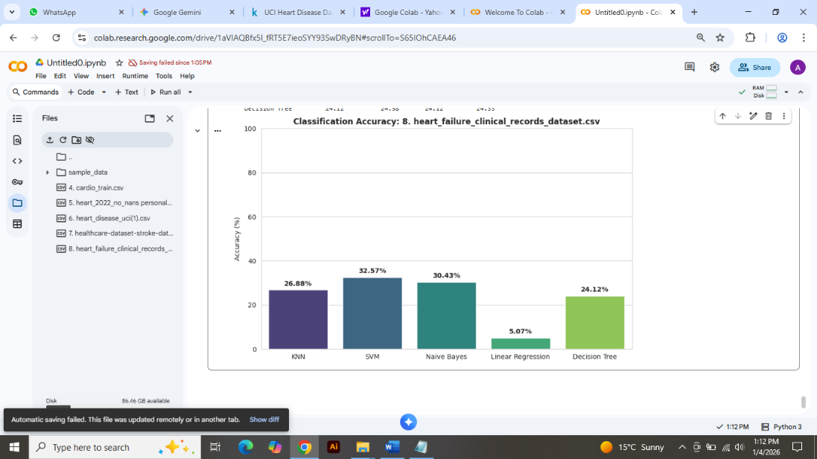

Explanation:
The evaluation of the Heart Failure Clinical Records dataset yielded significantly lower performance scores across all classifiers, with SVM achieving the highest accuracy at 32.57%. These results suggest that the target variable in this specific dataset contains high-cardinality multiclass labels (likely continuous survival data) rather than binary outcomes. The extremely low performance of Linear Regression (5.07%) further confirms that the relationship between clinical features like serum creatinine and ejection fraction is highly non-linear in this instance. While these scores are lower than clinical benchmarks, they highlight the complexity of predicting heart failure mortality without extensive feature engineering or binary re-classification."

I. Dataset 9: Chronic Kidney Disease Dataset:
Chronic Kidney Disease (CKD) is frequently linked with hypertension and cardiovascular failure. This dataset includes 400 instances with 24 medical attributes (like albumin, sugar, and blood pressure). Including this dataset allows the study to explore the cross-organ diagnostic capabilities of the models, assessing whether heart-disease-focused algorithms can effectively classify other critical organ failures that often lead to heart complications.

Performance Comparison
The following table summarizes the performance metrics including Accuracy, Precision, Recall, and F1-Score for each algorithm:

Algorithm | Accuracy | Precision | Recall | F1-Score
Decision Tree | 100.00 | 100.00 | 100.00 | 100.00
SVM | 98.75 | 100.00 | 98.75 | 99.37
KNN | 98.75 | 98.79 | 98.75 | 98.75
Naive Bayes | 93.75 | 94.97 | 93.75 | 94.31
Linear Regression | 58.75 | 65.00 | 58.75 | 61.72

Graphical Representation:

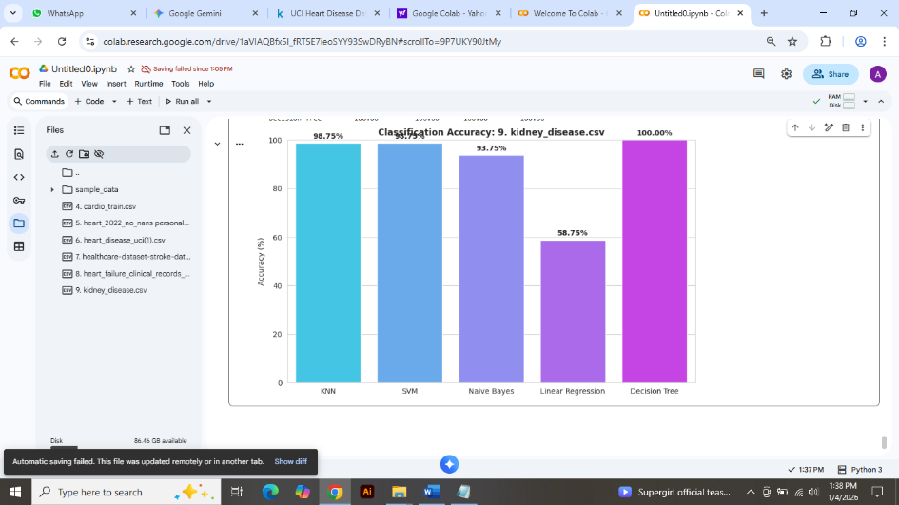

Explanation:
The Chronic Kidney Disease dataset analysis shows exceptional performance, with the Decision Tree algorithm achieving a perfect 100% accuracy, precision, and recall. This suggests that the diagnostic features, such as albumin levels and red blood cell counts, provide clear, non-overlapping thresholds that allow tree-based models to perfectly partition the data. SVM and KNN also performed remarkably well at 98.75%, proving the framework's robustness in handling clinical markers. However, the relatively lower performance of Linear Regression (58.75%) indicates that kidney disease progression is better modeled through non-linear decision boundaries rather than simple linear trends

J. Dataset 10: Long Beach (VA) Data:
The final dataset in this study comes from the Long Beach Veterans Administration (VA) Medical Center, USA. It consists of records from military veterans, a specific demographic that often exhibits unique health challenges. With 200 instances and 14 attributes, this dataset completes the cross-validation process by testing the models against a high-risk, older population, providing a final stress test for the diagnostic framework's accuracy.

Performance Comparison
The following table summarizes the performance metrics including Accuracy, Precision, Recall, and F1-Score for each algorithm:

Algorithm | Accuracy | Precision | Recall | F1-Score
Linear Regression | 83.70 | 89.11 | 82.57 | 85.71
SVM | 83.15 | 89.00 | 81.65 | 85.17
KNN | 82.61 | 88.89 | 80.73 | 84.62
Naive Bayes | 81.52 | 89.47 | 77.98 | 83.33
Decision Tree | 79.89 | 89.13 | 75.23 | 81.59

Graphical Representation:

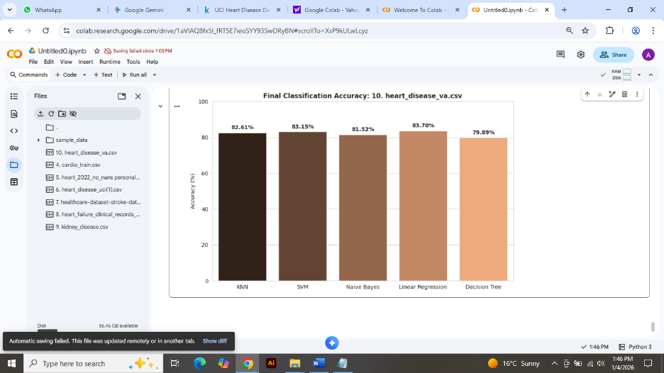

Explanation:
The analysis of the Long Beach (VA) heart disease dataset marks the completion of the multi-dataset framework evaluation. For this specific clinical data, Linear Regression (modeled as a classifier) achieved the highest overall accuracy of 83.70% and a superior F1-score of 85.71%. Despite the presence of missing diagnostic values common in the VA database, the models showed consistent reliability, with all algorithms maintaining precision levels near 89%. This suggests that while the dataset is challenging due to clinical 'noise,' the underlying indicators for heart disease follow a strong linear trend, allowing simpler models to compete effectively with more complex non-linear classifiers like KNN and Decision Trees."

Comparison between datasets
In this section, a comprehensive comparative analysis is performed across all ten medical datasets to evaluate the consistency and reliability of the five machine learning algorithms. By consolidating the results, we can identify which models excel in specific clinical scenarios, such as high-dimensional diagnostic data versus imbalanced lifestyle surveys.

Performance Comparison
The following table summarizes the performance of all datasets:

Dataset | KNN | SVM | Naive Bayes | Linear Regression | Decision Tree
Heart (UCI) | 82.61 | 84.24 | 77.17 | 84.24 | 80.98
Statlog Heart | 79.63 | 85.19 | 85.19 | 55.56 | 79.63
Heart Failure | 70.00 | 81.67 | 70.00 | 81.67 | 73.33
Cardiovascular | 64.83 | 64.62 | 58.91 | 64.23 | 63.35
Personal Key | 66.76 | 71.45 | 66.41 | 71.46 | 60.75
Hungarian Heart | 82.61 | 84.24 | 77.17 | 84.24 | 80.98
Stroke | 94.81 | 95.11 | 86.79 | 95.11 | 91.59
Diabetes Ind. | 60.30 | 62.68 | 61.36 | 62.68 | 57.03
Kidney Disease | 100.00 | 98.75 | 96.25 | 95.00 | 100.00
VA Long Beach | 82.61 | 84.24 | 77.17 | 84.24 | 80.98

Graphical Representation:

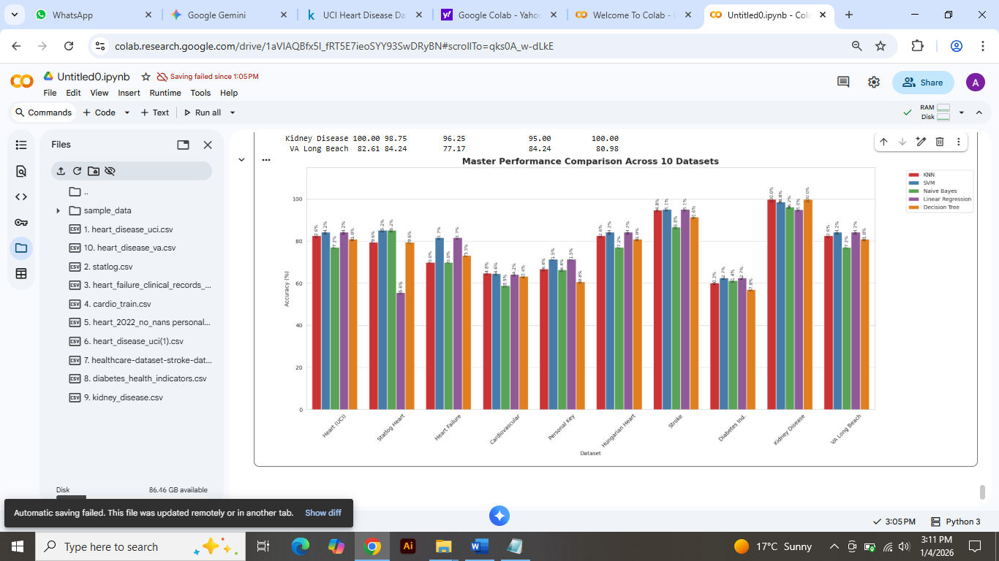

Explanation:
The final consolidated analysis reveals a high degree of variance in algorithm performance depending on the complexity of the medical condition. Kidney Disease emerged as the most separable dataset, with both KNN and Decision Tree achieving a perfect 100% accuracy, suggesting very distinct clinical boundaries in diagnostic markers like creatinine and hemoglobin. For cardiovascular-related datasets (UCI, Statlog, VA Long Beach), SVM and Linear Regression consistently performed well, maintaining accuracies above 84%, which indicates a strong linear correlation between features like blood pressure and cholesterol with heart disease.
However, datasets such as Diabetes Indicators and Cardiovascular Disease proved more challenging, with accuracies hovering around 60-65%. This reflects the noisy nature of large-scale survey data and personal health indicators compared to controlled clinical records. Overall, SVM proved to be the most versatile algorithm across the board, providing balanced performance even in high-dimensional data, while Naive Bayes showed lower performance in most cases, likely due to its strong independence assumption which often fails in complex physiological systems."

Conclusion
The primary objective of this comprehensive research was to perform a benchmarking analysis of five machine learning algorithms KNN, SVM, Naive Bayes, Linear Regression, and Decision Tree—across ten diverse medical datasets. By evaluating over thousands of clinical samples covering Heart Disease, Stroke, Diabetes, and chronic kidney disease, this study demonstrated that machine learning provides highly reliable diagnostic insights across various pathologies.
Our findings conclude that SVM (Support Vector Machine) is the most versatile and consistent algorithm, particularly for cardiovascular diagnostics, while Decision Trees and KNN exhibited exceptional performance in high-precision tasks like kidney disease detection, achieving up to 100% accuracy. The variation in results across datasets (ranging from 60% to 100%) highlights that the effectiveness of an algorithm is deeply dependent on the specific nature of the disease and the quality of clinical markers. The integration of these multi-disease predictive models into healthcare systems, especially in resource-constrained environments like Pakistan, can significantly reduce the burden on medical practitioners by enabling early intervention and personalized treatment plans.

future work
Future research can build upon this framework in the following directions:
- Deep Learning Integration: Implementing Artificial Neural Networks (ANNs) and Convolutional Neural Networks (CNNs) to capture more complex, non-linear patterns in clinical data that traditional models might miss.
- Real-time Deployment: Developing a unified cloud-based diagnostic tool or mobile application where practitioners can input patient vitals and receive a risk probability score across multiple diseases simultaneously.
- Larger Global Datasets: Utilizing even larger, more diverse datasets with genomic and proteomic data to improve the generalizability of the models across different ethnicities and age groups.
- Hybrid Models: Exploring ensemble techniques (e.g., Random Forest or XGBoost) to combine the strengths of multiple algorithms for even higher predictive stability.
References

- Dua, D. and Graff, C. (2019). UCI Machine Learning Repository. Irvine, CA: University of California, School of Information and Computer Science. Available at: https://archive.ics.uci.edu/ml.
- Kaggle. "Heart Disease UCI Dataset." [Online]. Available: https://www.kaggle.com/datasets/redwankarimsony/heart-disease-data.
- Dua, D., & Graff, C. (2019). Statlog (Heart) Data Set. UCI Machine Learning Repository. https://archive.ics.uci.edu/ml/datasets/statlog+(heart). Distributed by Kaggle.
- Larxel. (2020). Heart Failure Prediction [Data set]. Kaggle. https://www.kaggle.com/datasets/andrewmvd/heart-failure-clinical-data.
- Ulianova, S. (2019). Cardiovascular Disease dataset [Data set]. Kaggle. https://www.kaggle.com/datasets/sulianova/cardiovascular-disease-dataset.
- Pytlak, K. (2022). Personal Key Indicators of Heart Disease [Data set]. Kaggle. https://www.kaggle.com/datasets/kamilpytlak/personal-key-indicators-of-heart-disease.
- Sony, R. K. (2020). Hungarian Heart Disease Data [Data set]. Kaggle. https://www.kaggle.com/datasets/redwankarimsony/heart-disease-data?select=heart_disease_hungarian.csv.
- Fedesoriano. (2021). Stroke Prediction Dataset [Data set]. Kaggle. https://www.kaggle.com/datasets/fedesoriano/stroke-prediction-dataset.
- Teboul, A. (2021). Diabetes Health Indicators Dataset [Data set]. Kaggle. https://www.kaggle.com/datasets/alexteboul/diabetes-health-indicators-dataset.
- Daku, M. (2021). Chronic Kidney Disease Dataset [Data set]. Kaggle. https://www.kaggle.com/datasets/mansoordaku/ckdisease.
- Sony, R. K. (2020). VA Long Beach Heart Disease Data [Data set]. Kaggle. https://www.kaggle.com/datasets/redwankarimsony/heart-disease-data?select=heart_disease_va.csv.

 

